Finding Facts in American FactFinder
By
Paul H. Bern, Ph.D.
May 2012

The easiest thing to do is to simply enter the name of the city, town, county, etc into the search box on the main FactFinder page:

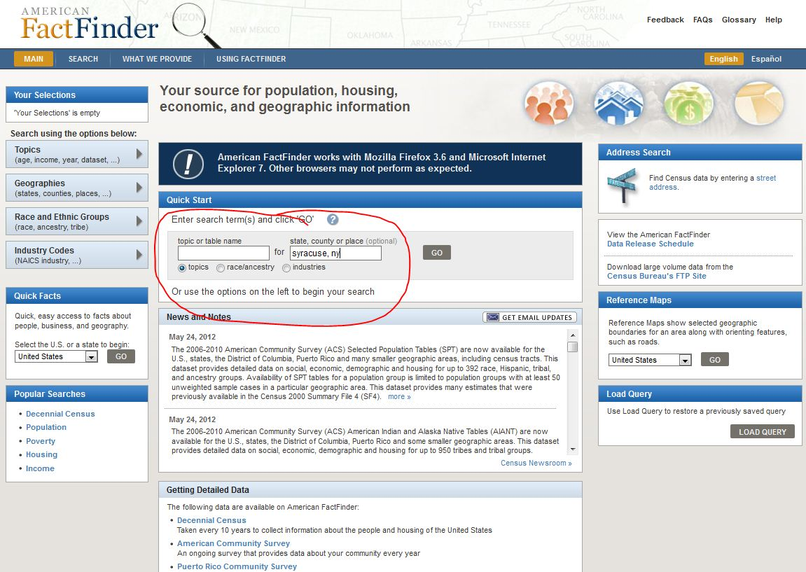

This will produce a list of all data available for that geographic area:

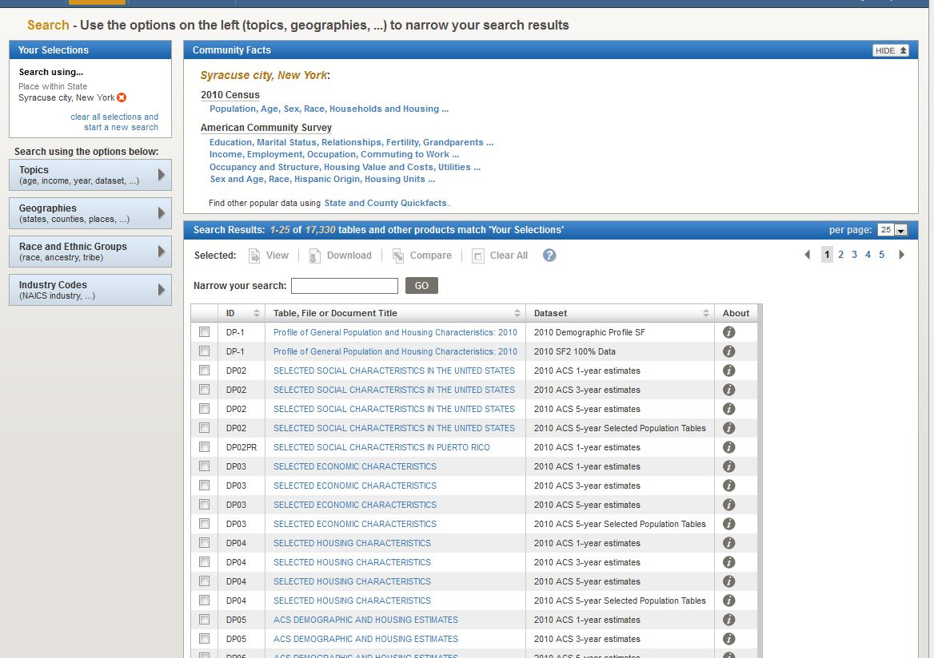

Sometimes you will want data for areas smaller than a city or county, such as census tracts, block groups and blocks. To get these, click on the Geographies search tab, then on the Name tab in the search window:

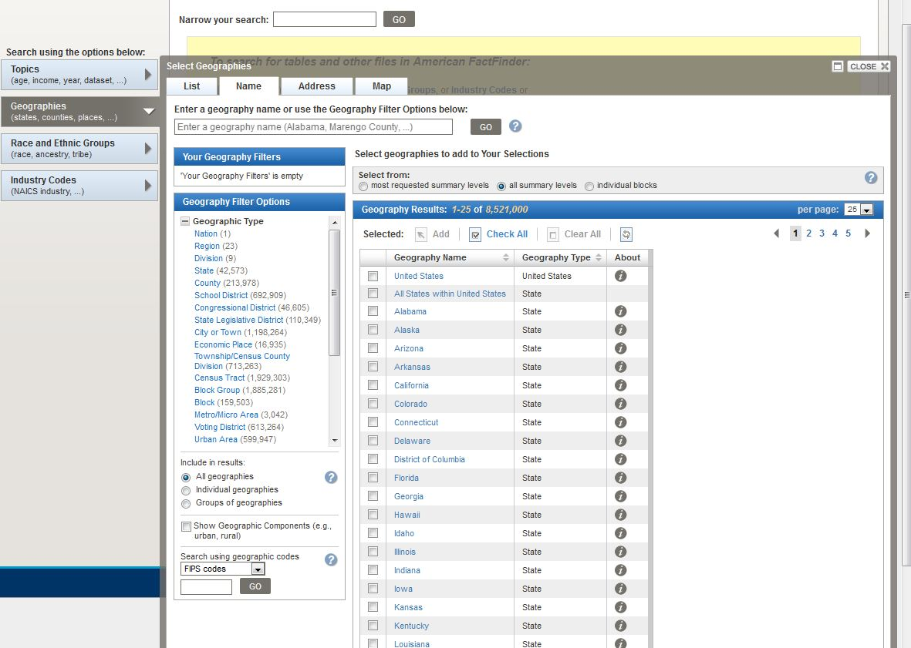

Make sure that “All summary levels” in the “Select from” section is selected as is “Groups of geographies” in the “Include in results” section. Then type the name of the city, county, etc in the search box and click “Go.”

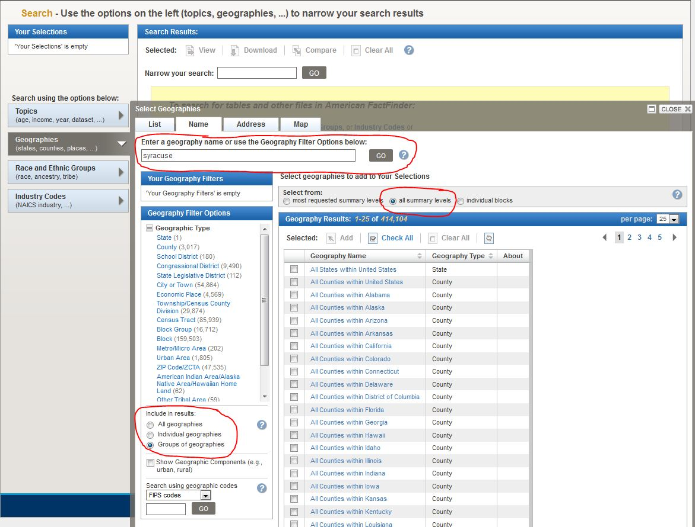

FactFinder will display a list of all geographies available for that area.

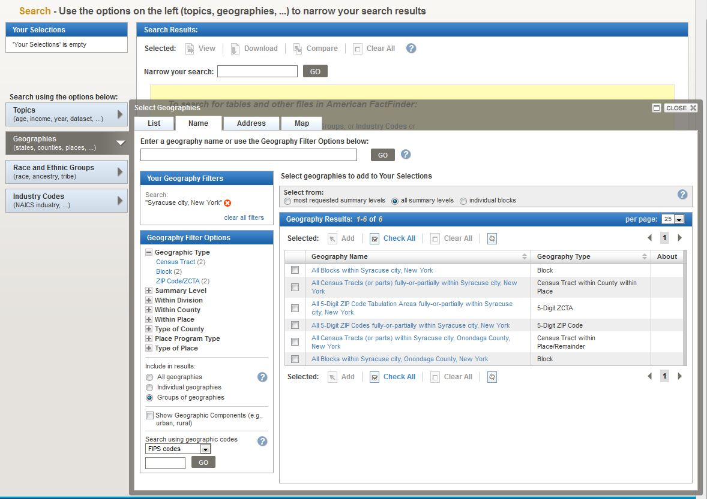

Select which type of geography you want and click “Add.” When you are done, close the search window.
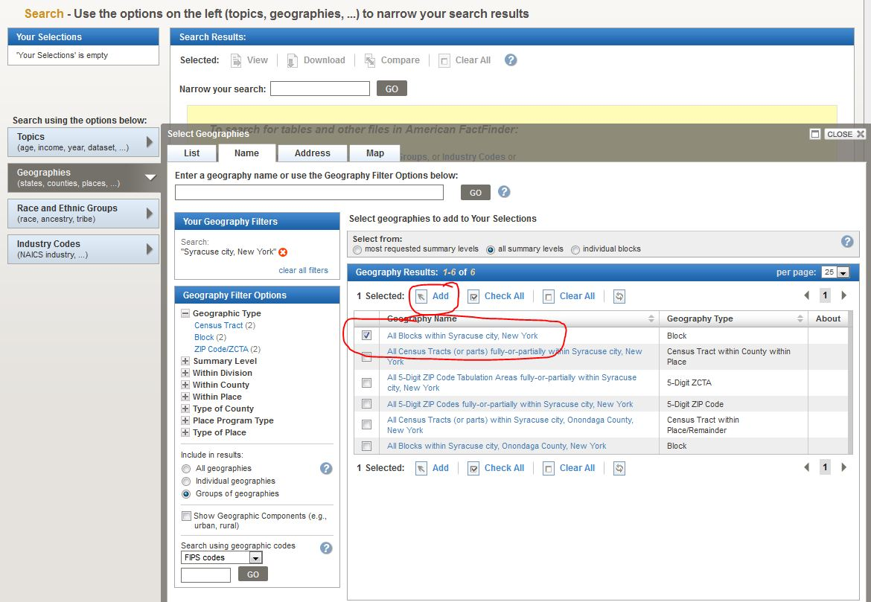

FactFinder will display all the tables available for your selections. You can narrow down your results by either typing a search term in the “Narrow your search” box or by clicking on the “Topics” tab on the left and browsing through categories of data.

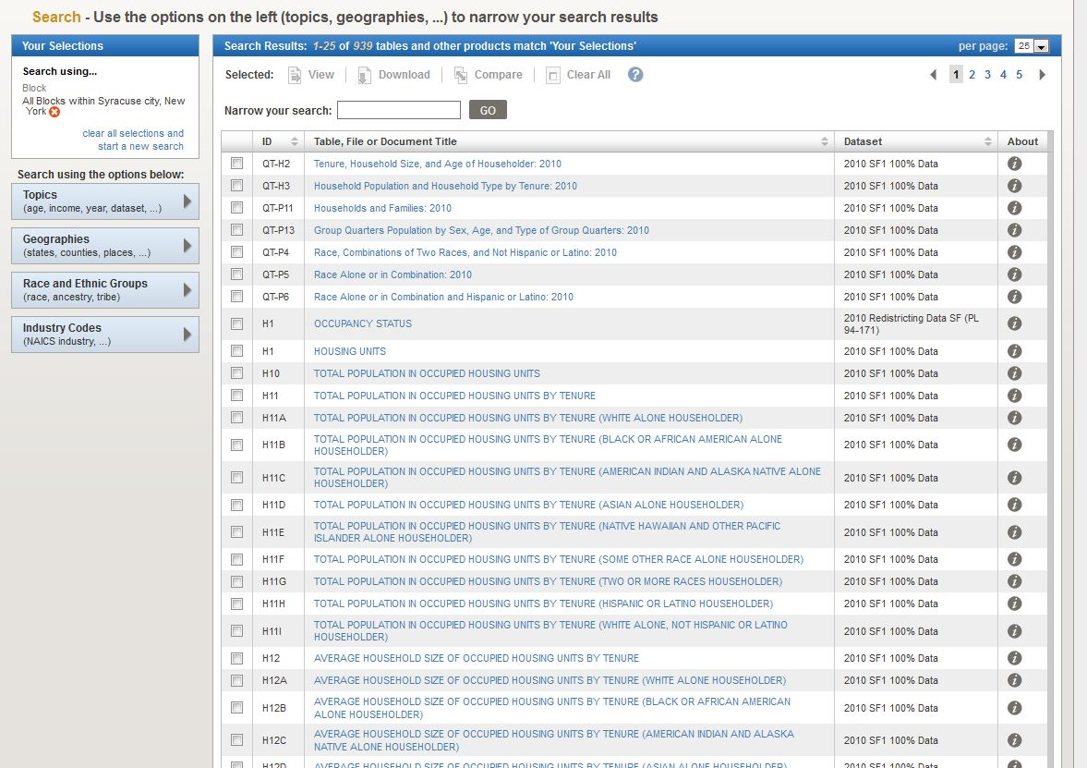
Select which tables you want and click “View.”
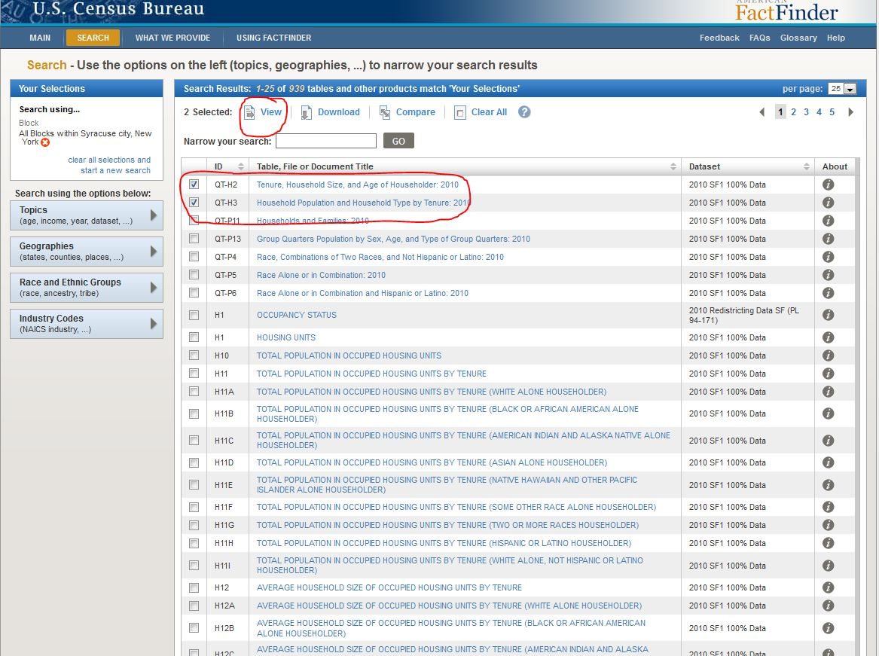
Depending on what geographies and tables you choose, FactFinder may divide the results over two or more pages.

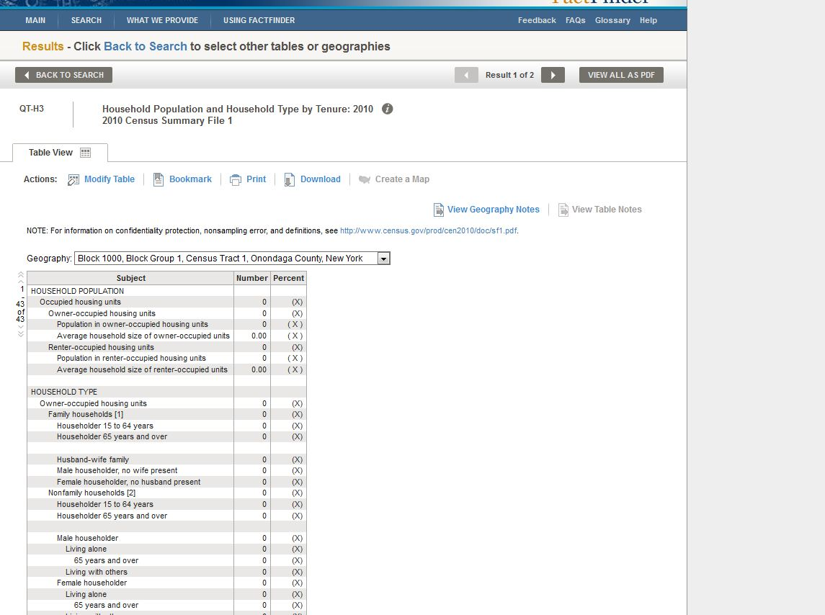
You can modify the table by transposing the rows and columns, selecting categories to display, as well as sorting the rows.

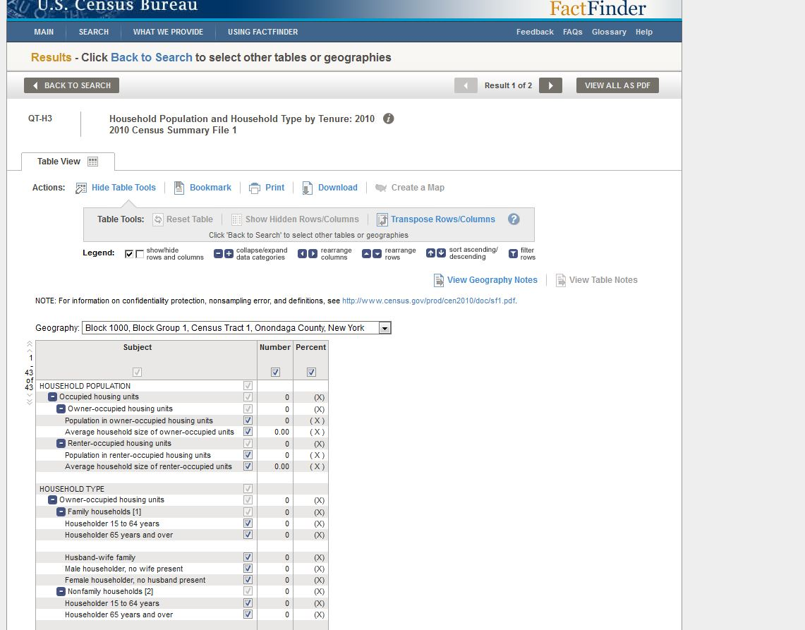
You can (and should) save the results of your query by either bookmarking it or saving the query parameters in a file and loading it on the main AFF page.

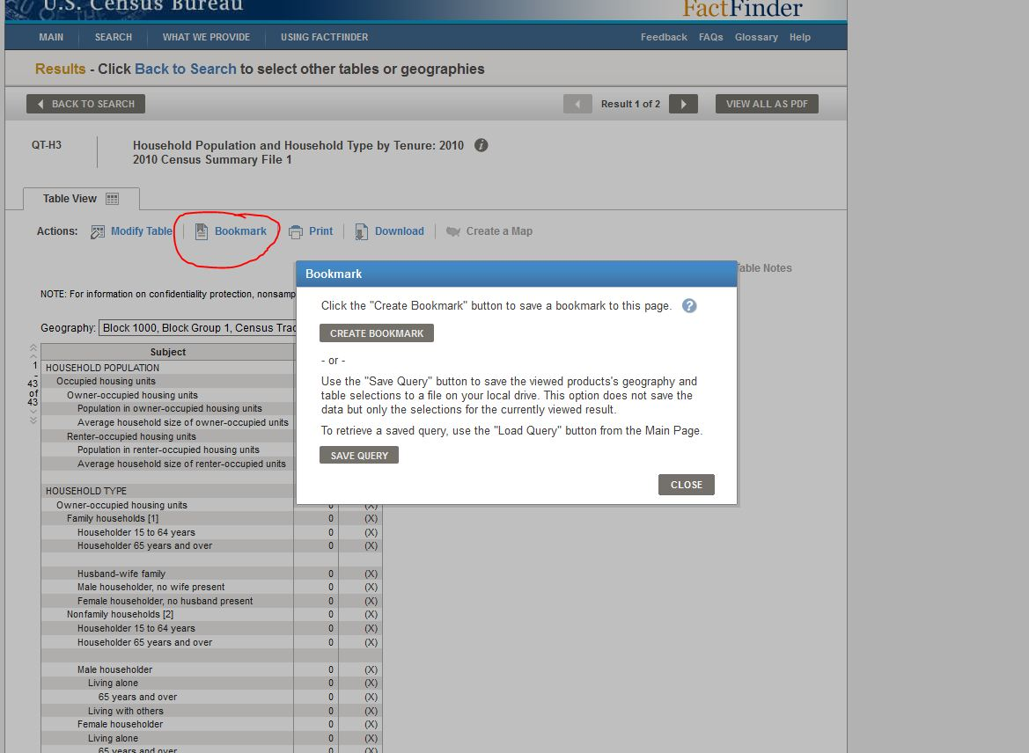

You can also download the results in several formats. If you want to manipulate the data or create charts, you will want to use the “Comma delimited (.csv) format” choice. Whether you want the annotations in the same or a separate file is a matter of choice. FactFinder will create a zip file containing three or more files, depending on your choices.
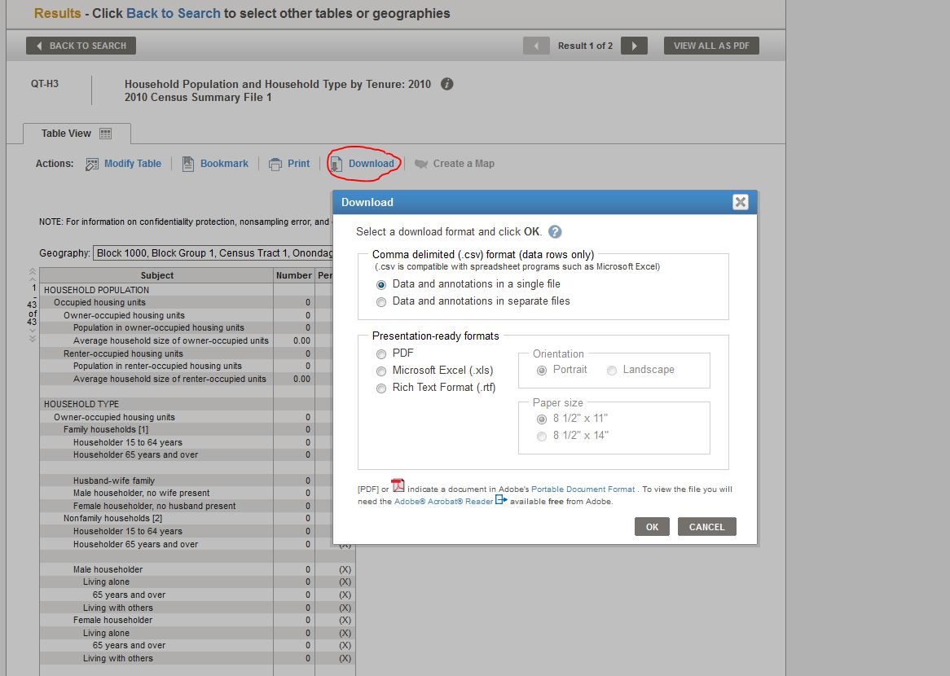
This is what the excel file will look like:

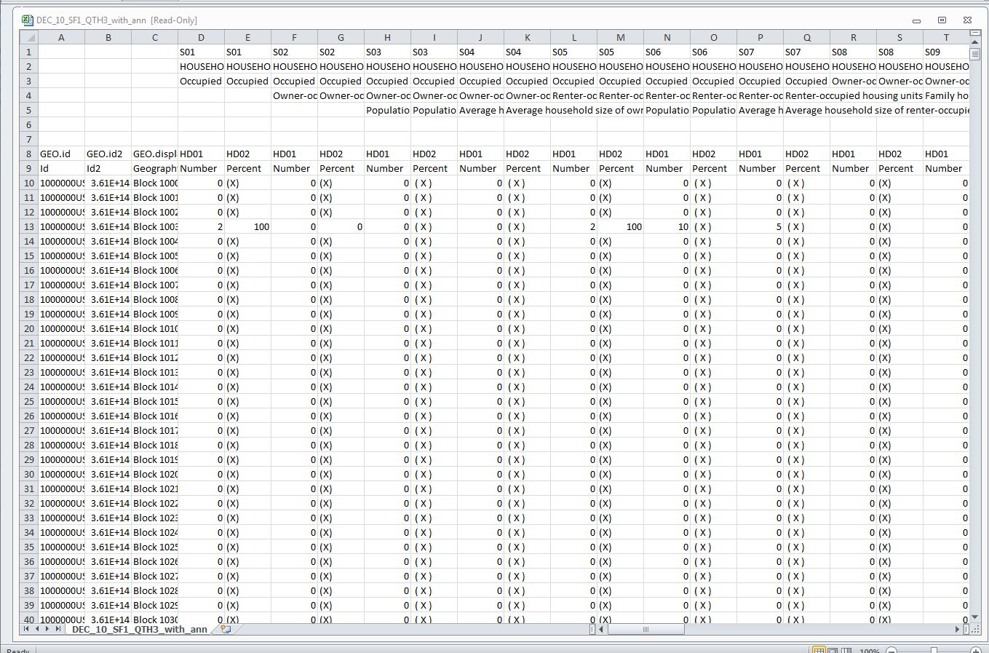
You’ll want to expand some of the columns to see the data better. The GEO.id2 column is read as scientific format, so you’ll want to highlight the entire column and set the format to “Number” and take out the decimals. Also, the Geography column has the various levels as a single value (cell). This will make grouping by Block Group, Census Tract, etc difficult. These can be split into separate columns, though. The first step is to insert some blank columns next to the Geography column – as many columns as you have levels in the Geography values (in this example there are five).

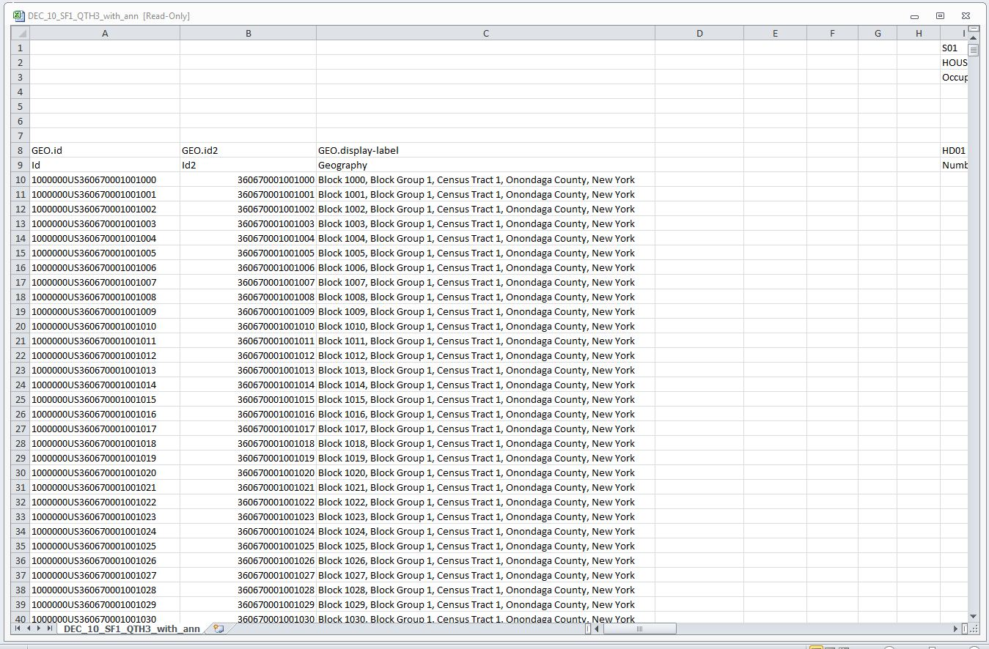

Click on the “Text to Columns” button in the “Data” tab. The wizard will open. Make sure you select “Delimited” in Step 1, then click “Next”.

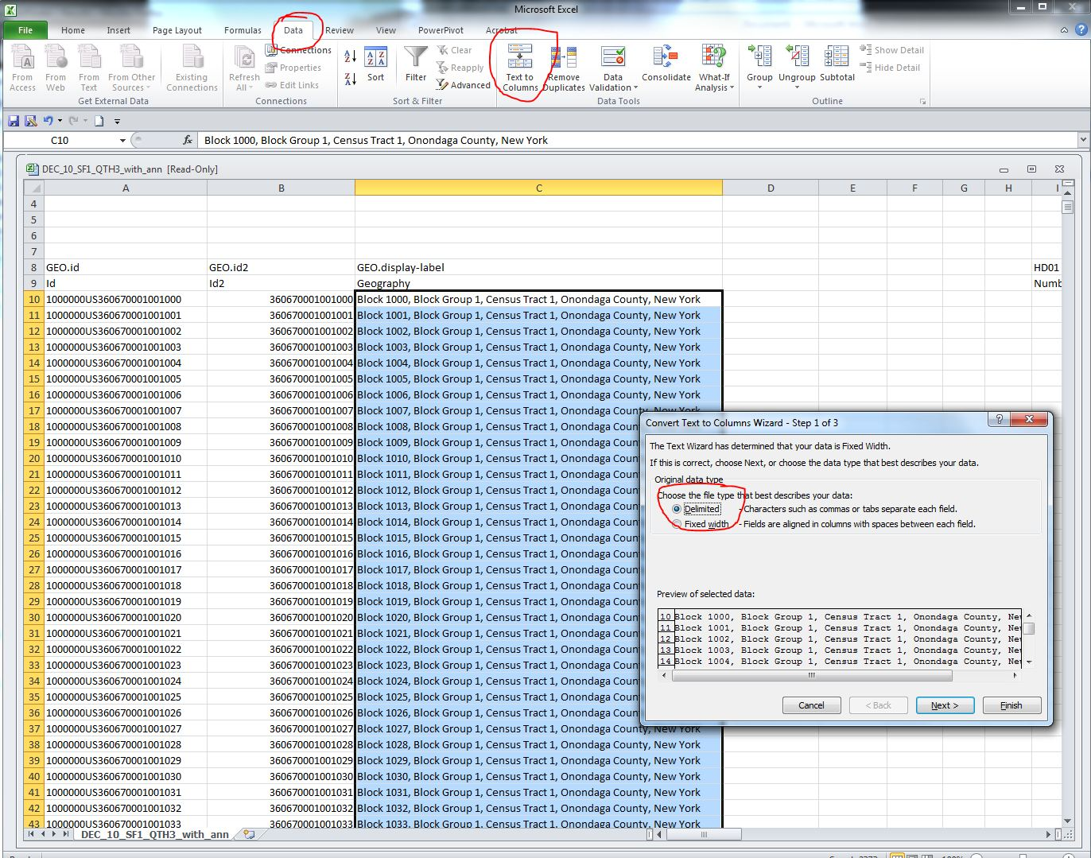

In Step 2, select “Comma” as the delimiter and uncheck any others.

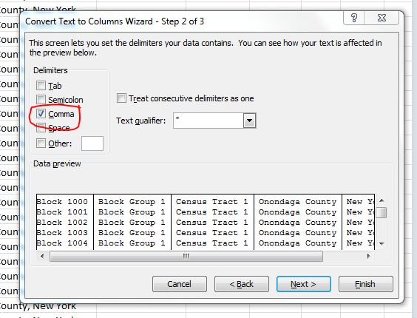

In Step 3, indicate the destination cell/column for the results – this would be the first blank cell/column next to the Geography column. Then click “Finish.”

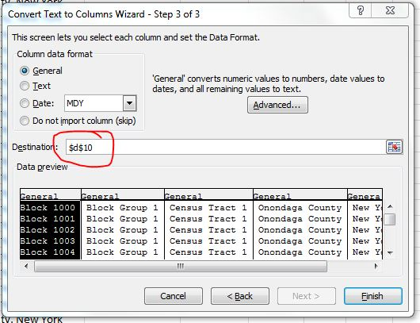
The various levels of Geography will be expanded into the blank columns you inserted earlier.

